EU- Declaration of conformity for medical devices
(According to Regulation (EU) 2017/745 for medical devices, Annex VIII of May 2017)

Manufacturer: HAIDER BIOSWING GmbH
SRN: DE-MF-000008765

We hereby declare under our sole responsibility that the sensorimotor therapy device PROPRIOMED ®

Type: BIOSWING® PROPRIOMED ® 100

Basic-UDI-DI: 4260742520051

Serial number: 2021: 2521000000 to 2521999999
2022: 2522000000 to 2522999999
(further ongoing)

complies with the relevant provisions of the following directive:

Regulation (EU) 2017/745 for medical devices

Classification according to Regulation (EU) 2017/745 for medical devices, Annex VIII:

Class I non-active medical device,

according to classification rule 1

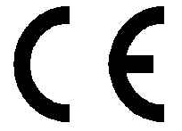

95704 Pullenreuth, Germany, May 26th, 2021

Management Technical Manager
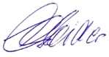
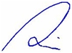

……………………………… ………………………………
Eduard Haider Dipl.-Ing. Alexander Haider

